SRINIVAS UNIVERSITY
Mangalore-575001, Karnataka (India)

RESEARCH SCHOLAR’S PROFILE

Mr VINAYACHANDRA
HoD, Computer Science
St Philomena College, Puttur, D.K. 574202 KARNATAKA
ORCID iD : 0000-0002-9374-4871

Research Area – IoT Solution Development:
The life is made easy by the IoT, which promised transformation in the way we work, we live, we play, we analyze and we think. The influence of IoT is seen everywhere today, from consumer products to military equipment, from motorbikes to airplanes, from manufacturing units to industries, and from daily use items to utility components and from house to smart cities. The everyday use objects which are being combined with Internet connection and data analytics capabilities guarantee ease of doing work, ease of living, ease of analyzing, ease of thinking and ease of playing. In essence, IoT provides a flat-form to interconnect various electronic devices through the Internet and open up a new world of possibilities. A few of them have already been explored and there is a great amount of it is waiting in. In the coming years IoT is expected to be one of the main hubs between various technologies by connecting smart physical objects together and allow different applications in support of smart decision making. Opportunities are in abundance to Explore, Experiment, and Expedite IoT.

Objectives:
This research center's goal is to review existing solutions and develop new IoT solutions for both end-users and industry. Analyzing and proposing new technologies to allow IoT to occur.
- To familiarize IoT Application Development.
- To review and develop IoT solutions for end-users and Industry.
- To comprehend enabling technologies for IoT.

Journal Publications:
- Vinayachandra, & Krishna Prasad, K. (2019). Executing Product Broadening Procedures for the Sustainability of an Innovation Organization - A Contextual Analysis of Microsoft Corporation. International Journal of Case Studies in Business, IT, and Education (IJCSBE), 3(2), 28-40.
- Vinayachandra, & Krishna Prasad, K. (2020). IoT Solutions Industry Prospects Analysis with Specific Reference to Mobiloitte Inc. International Journal of Case Studies in Business, IT, and Education (IJCSBE), 4(1), 64-78.
- Vinayachandra, &Krishna Prasad, K.(2020). Integrated Intelligent Education System using Adaptive IoT Technology. International Journal of Applied Engineering and Management Letters (IJAEML), 4(1), 76-92.
- Krishna Prasad, K., Vinayachandra, K., Geetha Poornima, & Rajeshwari, M. (2020). Literature Review of Applications of ICT on Solar Cold Chain. International Journal of Applied Engineering and Management Letters (IJAEML), 4(1), 93-111.
- Krishna Prasad, K., Vinayachandra, K., Geetha Poornima, & Rajeshwari, M. (2020). An Integrated Solution for Solar Cold Chain Portfolio Management using Internet of Things. International Journal of Applied Engineering and Management Letters (IJAEML), 4(1), 112-130.
- Krishna Prasad K, Vinayachandra, GeethaPoornima K, Rajeshwari M (2020). Effect of COVID-19 on Technology Penetration: a Predictive Analysis. Alochana Chakra Journal, 9(5), 2949-2967.
- Vinayachandra, & Krishna Prasad, K. (2020). Application of IoT in the Development of Intelligent Education System – A Thematic Literature Review. International Journal of Management, Technology, and Social Sciences (IJMTS), 5(1), 124-146.
- Vinayachandra, K., Geetha Poornima, M., Rajeshwari & Krishna Prasad, K. (2020). Role of Technology in the Development of Smart and Secure Public Voting Systems – a Review of Literatures. International Journal of Management, Technology, and Social Sciences (IJMTS), 5(1), 298-317.
- Vinayachandra, K., Geetha Poornima, M., Rajeshwari & Krishna Prasad, K. (2020). A Conceptual Framework for the Integrated, Smart and Secure Remote Public Voting System (SSRPVS). International Journal of Management, Technology, and Social Sciences (IJMTS), 5(1), 318-334.
- Vinayachandra, Poornima, K. G., Rajeshwari, M., & Prasad, K. K. (2020). Arduino Based Authenticated Voting Machine (AVM) using RFID and Fingerprint for the Student Elections.Journal of Physics: Conference Series, 1712 012004.
- Geetha Poornima K. et al. (2020). Integration of Adaptive Technologies with Healthcare for the Early Identification and Control of COVID-19 Pandemic Disease. International Journal of Health Sciences and Pharmacy (IJHSP), 4(2), 5-28.
- Rajeshwari M, Vinayachandra, Geetha Poornima K& Krishna Prasad K. (2020). Web-Oriented Things Systems with 5T Policy to Manage and Contain COVID-19. International Journal of Applied Engineering and Management Letters (IJAEML), 4(2), 138–158.
- Krishna Prasad K., Aithal P. S., Geetha Poornima K., &Vinayachandra, (2021). Tracking and Monitoring Fitness of Athletes Using IoT Enabled Wearables for Activity Recognition and Random Forest Algorithm for Performance Prediction. International Journal of Health Sciences and Pharmacy (IJHSP), 5(1), 72-86
- Krishna Prasad, K., Aithal, P. S., Geetha Poornima, K., & Vinayachandra, (2021). An AI-based Analysis of the effect of COVID-19 Stringency Index on Infection rates: A case of India. International Journal of Health Sciences and Pharmacy (IJHSP), 5(1), 87-102
- Vinayachandra, Geetha Poornima K., Rajeshwari, M. & Krishna Prasad, K. (2021). Students’ Perception of the Effectiveness of Technology Assisted Online Education DuringCOVID-19 Pandemic: An Empirical Study. International Journal of Management,Technology, and Social Sciences (IJMTS), 6(1), 203-225.
- Geetha Poornima K., Vinayachandra, Rajeshwari M. & Krishna Prasad K. (2021). The Effect of Integration of Different Online Education Methods on Educational Advancement and Student Development: A Study. International Journal of Case Studies in Business, IT, and Education (IJCSBE), 5(1), 200-220.
- Rajeshwari M, Vinayachandra, K, Geetha Poornima and K, Krishna Prasad, An Analysis into the Contribution of Google Applications in the Successful Implementation of Online Education During the COVID-19 Pandemic (June 2021). International Journal of Applied Engineering and Management Letters (IJAEML), 5(1), 131-152.
- Krishna Prasad K., Vinayachandra, Geetha Poornima, K., & Rajeshwari, M. (2021). Students’ Perceptions of the Impact of Online Education on Health during COVID-19: A Survey Study. International Journal of Health Sciences and Pharmacy (IJHSP), 5(2), 1-27.
- Geetha Poornima K, Vinayachandra, Rajeshwari M, & Bishwas Mishra (2021). An Analysis into the use of Supervised Learning Algorithms in Predictive Analytics. Sparkling light Transactions on Artificial Intelligence and Quantum Computing, 1(2), 1-20.

Publication in Conference Proceedings
- Vinayachandra& Krishna Prasad K. (2019). Implementing Product Diversification Strategies for The Sustainability of a Technology Company - A Case of Microsoft Corporation. Proceedings of International Conference on Emerging Trends in Management, IT and Education. ISBN: 978-81-941751-2-4.
- Vinayachandra& Krishna Prasad K. (2019). Premier IoT Solution Development Company –A Case of Mobiloitte. National Conference on Recent Advances in Technological Innovations in IT, Management, Education and Social Sciences.ISBN: 978-81-941751-6-2.
- Vinayachandra. (2020). “Comprehensive and Integrated Approach to Smart and Secure Public Voting System:. National Level Paper Contest for Ph.D. students. 21st November 2020. 31-36.ISBN: 978-81-944670-1-4

Book Chapters
- Vinayachandra, Geetha Poornima K, & Rajeshwari M(2020), IoT Adaption to Transform Smart Environmental Education, Information, Communications and Computation Technology (ICCT), Edited by P.K. Paul, P.S. Aithal, Subrahmanya Bhat and Krishna Prasad K,NEW DELHI PUBLISHERS, New Delhi India,Chapter10,pp. 173-204. ISBN: 978-93-88879-95-8,
- Vinayachandra & Krishna Prasad K (2020), ICCT implementation in the transition from traditional in-class, face-to-face teaching to remote learning – a study, Information, Communications and Computation Technology (ICCT),Edited by P.K. Paul, P.S. Aithal, Subrahmanya Bhat and Krishna Prasad K,NEW DELHI PUBLISHERS, New Delhi India, Chapter4,pp. 55-86.ISBN: 978-93-88879-95-8.
- Vinayachandra, Geetha Poornima, K & Rajeshwari M., Chapter-7 - Electronic Recycling and Disposal towards Ecological Promotion—A Systematic Study, ENVIRONMENTAL INFORMATION SCIENCES, ISBN: 978-93-88879-91-0, NEW DELHI PUBLISHERS 125-158,
Application for grant of patent
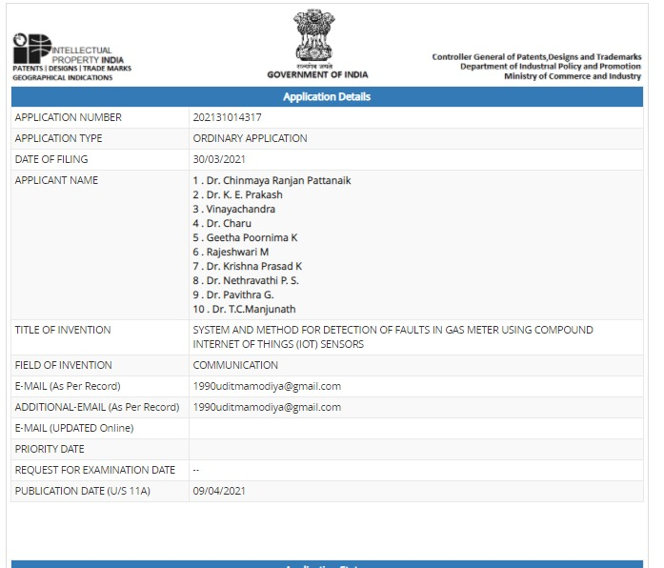

Working Papers:
- Blockchain for the Secure Processing of IoT Transactions -An Analytical Study
- A Systematic Approach to Smartand Secure Remote Public Voting System
- Blockchain for Securing Online Transactions– an overview.

Copyright
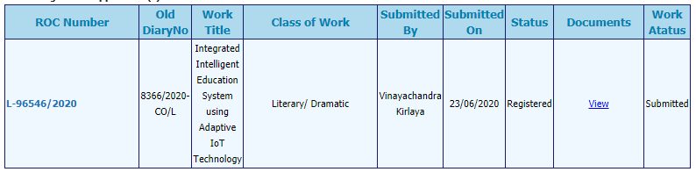

Membership in Professional Bodies
- IEEE Graduate Student Member – No. 96687258 (Bangalore Section)

Research Scholar:
Mr. Vinayachandra
HoD, Computer Science
St Philomena College, Puttur, D.K. 574202 KARNATAKA
&
Research Scholar,
College of Computer Science & Information Science
Srinivas University, City Campus, Mangaluru - 575001

E-mail: veeciashu@gmail.com, veeciashu@spcputtur.org
Personal Website : https://vinayakirlaya.blogspot.com/
College Website : www.spcputtur.org
University Website: www.srinivasuniversity.edu.in

Profile in Popular Research Work Uploading Sites
ResearchGate | https://www.researchgate.net/profile/Vinayachandra_Kirlaya
Google Scholar | https://scholar.google.com/citations?user=BhLqSbgAAAAJ&hl=en
ORCID | https://orcid.org/0000-0002-9374-4871
Academia.edu | https://independent.academia.edu/Vinayachandra
SSRN | https://papers.ssrn.com/sol3/cf_dev/AbsByAuth.cfm?per_id=3779701
Mendeley | https://www.mendeley.com/profiles/vinayachandra-kirlaya/

Research Guide:
Dr. Krishna Prasad K.
Associate Professor,
College of Computer Science & Information Science
Srinivas University, City Campus, Mangaluru – 575001

E-mail : krisshnaprasadkcci@srinivasuniversity.edu.in, karanikrishna@gmail.com
Personal Website: www.krishnaprasadk.website
College Website: www.srinivasgroup.com
University Website: www.srinivasuniversity.edu.in

